EX NO 9: Counting Identifiers in a C Program Using LEX

Aim:
To write a LEX program to read a C source file and count the number of identifiers, ignoring keywords, constants, comments, spaces, and special symbols.

Algorithm:
- Start the program.
- Define patterns to identify C keywords, identifiers, constants, and comments.
- Read the C source file as input.
- Ignore keywords, constants, comments, spaces, and special symbols.
- Count the occurrences of identifiers.
- Display the total number of identifiers.
- Stop the program.
Program:

%{
#include <stdio.h>
int count = 0;
%}

%%
"int"|"return"|"float"|"char"|"if"|"else"|"while"|"for"|"void" ;
[0-9]+ ;
"//".* ;
"/*"([^*]|\*+[^*/])*\*+"/" ;
[a-zA-Z_][a-zA-Z0-9_]* { count++; }
[ \t\n]+ ;
. ;
%%

int main()
{
yylex();
printf("Number of identifiers = %d\n", count);
return 0;
}

int yywrap()
{
return 1;
}
Sample output:
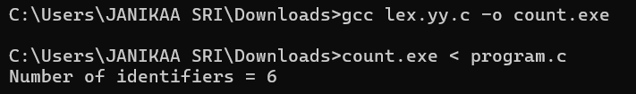

Result:
The LEX program was executed successfully and counted the identifiers present in the given C source program.

